**Use the diagram below to answer the configuration questions.**

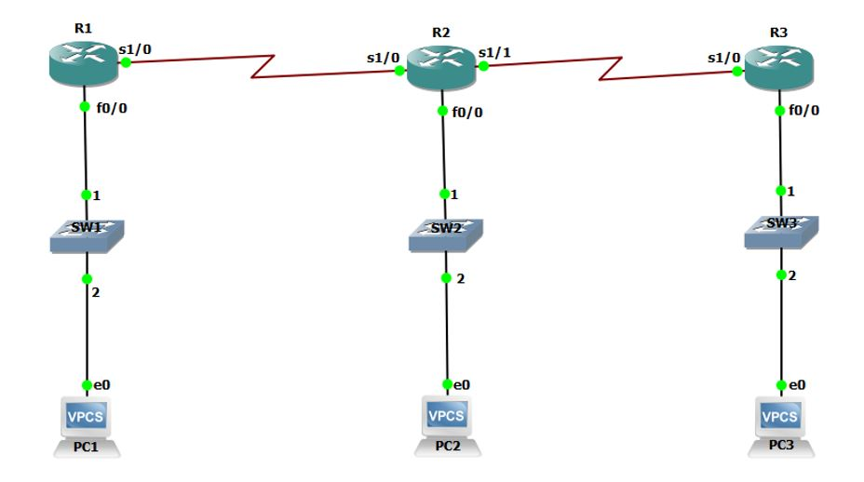

**(A) Initial Router configuration.**

         i) Change router hostname.

        ii) Configure line console.

       iii) Configure VTY.

       iv) Configure AUX.

        v) Configure enable password.

       vi) Configure secret password.

      vii) Encrypt all your passwords.

**(B) Configure Router Interfaces.**

**(C) Assign ip addresses to VPCs.**

**(D) Configure RIPv2 in all Routers.**

**(E) VPC1 MUST Ping VPC3.**

**Configuration Requirements.**

**Router 1:**

       s1/0             == 172.17.0.1 /16

      Switch 1:  f/0    == 172.16.0.1 /16

      VPC 1:             == 172.16.0.10 /16

**Router 2:**

          s1/0               == 172.17.0.2 /16

          s1/1                == 172.19.0.1 /16

         Switch 2: f0/0    == 172.18.0.1 /16

         VPC2:                == 172.18.0.10 /16

**Router 3:**

     S1/0                   == 172.19.0.2 /16

    Switch 3: f0/0     == 172.20.0.1 /16

       VPC 3:               ==  172.20.0.10 /16

[**ASSIGNMENT 3**](https://learn.stamford.edu/webapps/assignment/uploadAssignment?content_id=_1845891_1&course_id=_16948_1&group_id=&mode=view) **(solution)**:

The following topology was set up:

**A)Initial Router configuration:**

1. Change router hostname.
2. Configure line console
3. Configure VTY.
4. Configure AUX
5. Configure enable password.
6. Configure secret password.
7. Encrypt all your passwords.

**(B) Configure Router Interfaces:**

**(Before configuring)**

**(While Configuring router interfaces):**

**(After configuring):**

(After configuration):

**(C) Assign ip addresses to VPCs:**

**(D) Configure RIPv2 in all Routers.**

**(E) VPC1 MUST Ping VPC3:**

